Our Approach to Catholic Investing
At 1919, we have more than 50 years of experience managing socially responsive portfolios, including those for Catholic, faith-based investors. We are committed to helping our clients achieve their financial goals while staying true to their values and mission. While our work with Catholic individuals and institutions over the last five decades has evolved, it continues to focus on helping them avoid investing in companies that exhibit business practices inconsistent with the teachings of the Catholic faith and the guidelines established by the United States Conference of Catholic Bishops (USCCB).

The USCCB first issued social investing guidelines in 1991 and subsequently updated them in 2003 and again in November 2021. While the guidelines were established to guide the Conference’s own investments and corporate responsibility activities, many other Catholic individuals and institutions use them to direct their investments. The USCCB’s most recent Socially Responsible Investment (SRI) Guidelines are organized into five categories: Protecting Human Life, Promoting Human Dignity, Enhancing the Common Good, Pursuing Economic Justice, and Saving Our Global Common Home. The latest guidelines incorporate negative or exclusionary screening, but also outline a greater emphasis on active ownership and corporate engagement to affect positive social and environmental change. For the first time, the guidelines address new areas such as media, telecommunications and technology, and impact investing. The table below shows the broad topics that are covered.
1919’s comprehensive approach to Catholic investing is built on the USCCB SRI Guidelines and includes negative screening, a preference for positive impact, and corporate engagement. For a client’s portfolio, we eliminate companies that are involved in activities prohibited by the USCCB. When evaluating investment opportunities, our Responsible Investing Analysts consider how corporate behavior and practices align with the issues outlined in the USCCB Guidelines. We look for ways in which companies are having a beneficial impact in areas that are important to Catholic investors. Our approach also includes exercising shareholder rights and active ownership through proxy voting and informed corporate engagement. For example, we are longtime members of the Interfaith Center on Corporate Responsibility (ICCR) and we actively participate in collaborative engagement networks with aims to encourage greater corporate transparency.

Our Approach to Catholic Investing
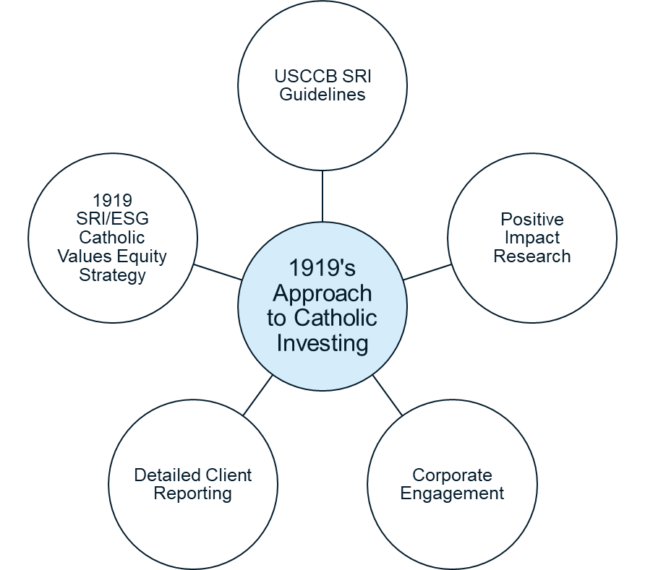

USCCB’s SRI Guidelines
Protecting Human Life | - Abortion  - Euthanasia  - Assisted Suicide  - In Vitro Fertilization  - Embryonic Stem Cell & Fetal Tissue Research  - Human Cloning  - Access to Pharmaceuticals
Promoting Human Dignity | - Human Rights  - Discrimination  - Pornography  - Human Trafficking  - Gender Reassignment Treatment  - Contraceptives
Enhance the Common Good | - Weaponry  - Civilian Firearms  - Gambling  - Tobacco  - Cannabis
Pursuing Economic Justice | - Labor Standards  - Corporate Responsibility Reporting  - Affordable Housing & Responsible Banking
Saving Our Global Common Home | - Climate Change  - Biodiversity  - Water & Natural Resources  - Environmental Principles
While our Catholic investing approach and the associated equity strategy we offer are based on the USCCB’s SRI Guidelines, we recognize that each client is unique. We work with each client to develop and implement responsible investing guidelines that support their financial and faith-based goals. Clients may utilize the USCCB Guidelines directly or design a customized set of guidelines according to their specific preferences. Our Catholic investing approach and the USCCB Guidelines can be applied to equity and fixed income investments.
We provide detailed reporting and commentary on each client’s portfolio, positive impacts, and issues of concern that may not meet the threshold for exclusion. Companies in our client portfolios are monitored on an ongoing basis to ensure they meet both our responsible investing and fundamental criteria.
We can help determine if Catholic investing is a fit for your objectives. Please contact 1919’s Responsible Investing team if you have any questions or would like additional information.

About 1919 Investment Counsel  1919 Investment Counsel, LLC is a registered investment advisor. Its mission for more than 100 years has been to provide counsel and insight that helps families, individuals, and institutions achieve their financial goals. The firm is headquartered in Baltimore and has regional offices across the country in Birmingham, Cincinnati, Houston, New York, Philadelphia, San Francisco and Vero Beach. 1919 Investment Counsel seeks to consistently deliver an extraordinary client experience through its independent thinking, expertise and personalized service. To learn more, please visit our website at 1919ic.com. | 1919 Responsible Investment Team  • 6 RI dedicated team members  • Comprehensive Responsible Investing Committee Process and Investment Review considering Client Values, ESG factors and Impact  • 50+ years managing Responsible Investments

Disclosures

Information stated herein is as of August 1, 2023 unless otherwise stated.

The information provided here is for general informational purposes only and should not be considered an individualized recommendation or personalized investment advice. No part of this material may be reproduced in any form without the express written permission of 1919 Investment Counsel, LLC (“1919”). This material contains statements of opinion and belief. Any views expressed herein are those of 1919 as of the date indicated, are based on information available to 1919 as of such date, and are subject to change, without notice, based on market and other conditions. There is no guarantee that the trends discussed herein will continue, or that forward-looking statements and forecasts will materialize.

Investing based on environmental, social and corporate governance (“ESG”) factors may cause a strategy to forgo certain investment opportunities available to strategies that do not use such criteria. Because of the subjective nature of socially responsible investing, there can be no guarantee that the ESG criteria used on a transaction-by-transaction basis will reflect the beliefs or values of any particular client. Additionally, 1919 must rely in part upon ESG-related information and data obtained through third-party reporting that may be incomplete or inaccurate, which could result in imprecisely evaluating an issuer's practices with respect to ESG factors.

There is no guarantee that the investment opportunities discussed herein will materialize or, if they do, that such opportunities will yield any level of return. All investments carry a degree of risk and there is no guarantee that investment objectives will be achieved.

This material has not been reviewed or endorsed by regulatory agencies. Third party information contained herein has been obtained from sources believed to be reliable, but not guaranteed.

1919 Investment Counsel, LLC is a registered investment advisor with the U.S. Securities and Exchange Commission. 1919 Investment Counsel, LLC, a subsidiary of Stifel Financial Corp., is a trademark in the United States. 1919 Investment Counsel, LLC, One South Street, Suite 2500, Baltimore, MD 21202. ©2023, 1919 Investment Counsel, LLC. MM-00000706

Published: August 1, 2023

United States Conference of Catholic Bishops Socially Responsible Investment Guidelines. November 2021. https://www.usccb.org

